Module 1 – Programing Basics

When X=4 and y =3, perform the bitwise operations & (and), |(or)

Write a program to display multiplication table of 12, refer the sample program output inline

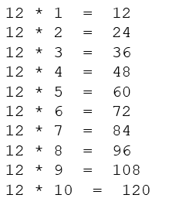

Write a program that takes marks of 5 subjects and display the grade, refer the sample program output Inline
Note – Use the inline Business logic while calculating grades:
If the average is greater than 90, “Grade: A” is printed.
If the average is in between 80 and 90, “Grade: B” is printed.
If the average is in between 70 and 80, “Grade: C” is printed.
If the average is in between 60 and 70, “Grade: D” is printed.
If the average is anything below 60, “Grade: F” is printed.

Write a program to demonstrate the usage of sample calculator, refer the sample program output inline

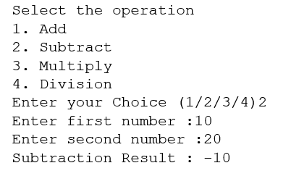
- Extend the previous program functionality, the calculator program to continue should continue indefinitely, until the user does not have any operation to continue.
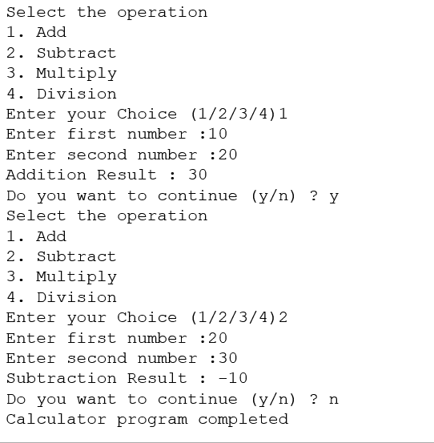

Additional Programs for Self-Practice

Write a python program to check if the input character is an alphabet or not, refer sample output inline

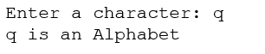

Python program to check whether the number entered by user is even or odd, refer sample program output inline

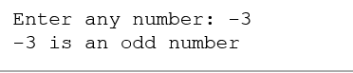

Module 2 – Data Structures/ Collections

Write a program to swap two elements of the list, refer sample program output inline

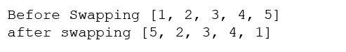

Write a program to sum all the list elements, refer sample program output inline

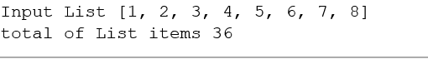

Write a program to find size of a sample list and tuple, also find the time taken to initialize a list and tuple 100000 times. Refer sample program input and outputs inline:

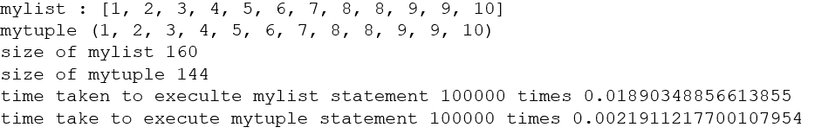

Write a program to demonstrate the set operation, union, intersection, difference and subset, refer sample program inputs an outputs inline

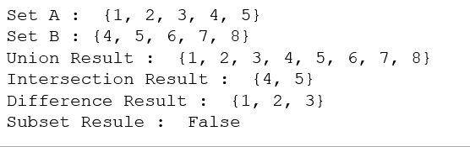

Write a Python script to

add a key to a dictionary.

Sample Dictionary : {'id': '59912', 'name': 'AAA', 'location': 'bengaluru'}

After update,

Expected Result : {'id': '59912', 'name': 'AAA', 'location': 'bengaluru', 'Salary': 500000)

Iterate over dictionary and display the key and values

Module 3 – File Operations

Write a program to read and display all the records present in the customers.txt file.

Enter/feed the below records in customers.txt file:
59912|Rakesh|Bengaluru
59913|Mahesh|Mumbai
59914|Rekha|Chennai

Write a program to find the number of records in cutomer.txt file

Write a program to display all the records form the file (customer.txt)

Write a program to write 3 transactions records to the file (transactions.txt), use the inline record format for reference:

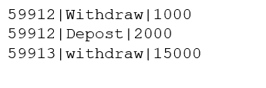

Append the inline 3 records to the transactions.txt file

